**Effect of Gun Control on the Crime Rate in the U.S.**

Nawen Deng, University of Texas at Austin

# Abstract

Many people died from gun-related crimes annually. The relationship between gun control and crime rates in the United States is an attractive topic for both freedom and security reasons. Using state-level data on crime rate, overall gun sales, and other interested independent variables, we generate a linear regression to indicate the effect of gun control on the crime rate in the U.S. Result finds the overall gun sales variable is not an important factor in determining crime rate with a p-value greater than 0.1. From policy perspective, widespread gun ownership does not contribute to a higher crime rate. However, we should not stop exploring new variants of gun control.

# Introduction

Gun control has long been an attractive topic for both freedom and security reasons. Regarding safety, many people are killed in gun-related crimes every year. Almost 40,620 people died from firearm-related crime, a rate of 12.5 deaths per 100,000 people (Everytown). From January 1st to October 6th, 2022, the Gun Violence Association recorded 519 mass shootings inside the U.S. (Gun Violence Archive, n.d.). A total of 523 people were killed and 2,183 injured in those 519 mass shooting cases (Gun Violence Archive, n.d.). Moreover, gun accessibility is closely linked with freedom. The United States is one of the three countries in the world that includes a constitutional right to grant gun ownership. The freedom of citizens to own firearms is rooted in the Second Amendment to the Constitution, which states: “A well-regulated Militia, being necessary to the security of a free State, the right of the people to keep and bear Arms, shall not be infringed” (The 2nd amendment).

Gun-related crime continuously happens in society. Meanwhile, the government continuously updates gun control laws. There is two gun-related crime that raised high levels of public attention in 2022. On May 24, 2022, three adults and nineteen children around 10 years old lost their lives in a shooting case at Robb Elementary School in Uvalde, Texas (Lynch, 2022). On the 14th of the same month, ten people were killed in the Saturday shooting at Buffalo supermarket in New York (Veronica et al., 2022). Seven days after the Texas elementary shooting case, a new act was introduced by Nadler Jerrold on May 31, 2022, and named

H.R.7910-Protecting Our Kids Act. This new gun control act states, “To amend title 18, United States Code, to provide for an increased age limit on the purchase of certain firearms, prevent gun trafficking, modernize the prohibition on untraceable firearms, encourage the safe storage of firearms, and for other purposes” (Rep. Nadler, 2022). However, imperfect information happens during government intervention. First, all the laws and acts are built upon existing detectable cases. However, some cases are undetected. Therefore, hidden facts that cannot be analysis can cause accessible information not to be all-encompassing, so there will be imperfections inside the existing laws and acts. Secondly, there is ignorance of the deeper motives behind shootings, like mental issues, social environment, and racism. Most of the time, deep motivations are hard to detect and easily ignored. Therefore, some laws and acts are established based on the cases’ appearance. Due to imperfect information from all degrees, it’s difficult to solve the problem in depth.

In addition to the legislation intervention in gun control, the government also highly focused on the profits generated from the gun market. Guns contribute more than $70 billion in 2021 (Morrissey, 2022). It has broad impacts throughout the economy. Guns even supported businesses unrelated to firearms. “Total jobs increased by over 33,000 in the same period, from 342,330 to 375,819. (Morrissey, 2022)” Besides the positive economic impact, gun violence follows with a huge amount of financial cost. The cost cannot be neglected. The annual gun violence cost including immediate cost, subsequence cost, and quality of life cost generate $557 billion. Therefore, the U.S. government’s myopic behavior toward gun control can be seen from this economic perspective.

Gun control is related to many factors: individual liberty, security, and government interest. Therefore, firearms-related research exists in a large variation. Gun-control supporters believe limitation on gun access can save more lives and reduce violence, people who are against gun control have concerns about self-defense against armed criminals, and there is a group of people who hold no specific opinions. This paper will further research this popular topic to detect the relationship between gun control and crime rates in the United States.The dependent variable is the crime index of each state, and the interested independent variable is the number of guns sold by each state between 2019-2020. The units will be the 50 states of the United States, and the data will be compared and analyzed to conclude the effect of gun control on the crime rate in the U.S.

# Literature review

After the occurrence of multiple large-scale school shootings, American society has conducted research and discussion on the topic of arming teachers and nonteaching staff to cope with emergencies. This has aroused broad social attention. There have always been articles documenting the impact of gun control on the crime rate. Ik-Whan G et al. published an article on the Effectiveness of Gun Control Law in August 2010. They statistically and empirically evaluated the effectiveness of gun control laws using state-level data. They divided states into two categories, with gun usage restriction and without gun usage restriction, to estimate the relationship between the number of gun-related death in 1990 and gun control law. Their result indicates that gun control laws have a very mild effect on gun-related death. While socioeconomic and law enforcement factors significantly affect the level of crime rate (Kwon, 2010). Grey et al (2016) estimated whether gun control reduces violent crime. Data are collected on every U.S. city with 25,000 or more population in 1990. This city-level cross-sectional study coded 19 cities that have major firearms restrictions. Dependent variable is the city violence rate covering all major violence that frequently involves guns: homicide, robbery, suicide, aggravated assault, and fatal gun accidence. Research result shows no impact of gun laws on total violence rates. In other words, the level of gun prevalence has no positive effect on total violence rate and most gun control restrictions do not affect violence rates (Kleck, 2016). Mathew published gun control legislation: Impact and Ideology in July 1983. They controlled for several standard social phenomena and used two different statistical techniques to estimate the relationship between state laws and the rates of firearm violence. Result of this study shows that state gun laws have little effect on the rate of firearm crime (DeZEE, 1983). Douglas R. Marry published Handguns, Gun Control Laws, and Firearm violence in August 2014. This article explored the relationship between handgun access, gun control laws, and firearm-related violence. National data from all fifty states are collected from F.B.I, census materials, vital statistic, and Harris and Gallup survey. After statistical analysis, the study result shows no significant relationship between gun control laws and rates of violence (Murray, 2014).

# Empirical Model

The effect of number of guns sold on crime rate can be related by Linear Regression as follows:

*Crime rate = β0 + β1 gun sales + β2 medium income + β3 poverty + β4 college graduation rate + β5 unemployment rate + β6 adult binge drinking prevalence + β7 race + β8 region + u*

*Crime rate* as the dependent variable measured the crime rate of each state per 100K people. *Gun sales* as the interested independent variable measures the approximate total number of firearms sold in each state.

*Medium income* is a variable that measures the medium annual household income in 2021. *Poverty* is a variable that measures the percentage of population who fall below the poverty line. *College graduation rate* variable measures the percentage of each state’s population with a college degree or higher. *Unemployment rate* variable measures the percentage that is unemployed. *Adult binge drinking prevalence* variable measures the adult binge drinking prevalence in percentage. *Race* variables controlled the U.S. population as Black, Indian, Asian, Hawaiian, and others. Where White is excluded from this study. *Region* variable controlled all states as North, South, East, and West. Where South is excluded in this study.

# Data

Crime rate data is collected from a survey released by the FBI called Crime in the United States 2020, and crime rates are calculated by Statista. The data can be accessed from <https://www.statista.com/statistics/301549/us-crimes-committed-state/>, including murder, rape, robbery, aggravated assault, burglary, larceny-theft, and motor vehicle theft crime.

Gun sales are state-level data created by a proprietary model from RobarGuns and use key data sources from the FBI’s National Instant Criminal Background Check System and gun dealers holding a Federal Firearms License. Data can be found and located at <https://robarguns.com/gun-sales-in-2020>. 18,924,584 overall firearms sold in the U.S. in 2020, which increased 47.78% from the previous year. The state with the highest number of guns sold in 2020 was Illinois with 1,811,581 guns sold. Texas had the second-highest number of guns sold with 1,339,362 units. And followed by Indiana with 1,114,898 guns sold.

Medium income measured medium annual household income of each state in 2021, and the data can be found at [https://www.kff.org/other/state-indicator/median-annualincome/?currentTimeframe=0&sortModel=%7B%22colId%22:%22Location%22,%22sort%22: %22asc%22%7D;](https://www.kff.org/other/state-indicator/median-annual-income/?currentTimeframe=0&sortModel=%7B%22colId%22:%22Location%22,%22sort%22:%22asc%22%7D) this variable is included because people with a higher level of wealth have greater ability and access to better community environment and higher education that have lower crime rate. Poverty variable measured the proportion of population based on the poverty line in a family of four - $27,479- in 2021, and the data is obtained from <https://www.americanprogress.org/data-view/poverty-data/poverty-data-map-tool/>; this variable was chosen because the stress of poverty can make people in difficult situations more likely to commit crimes. College graduation rate data, which measures the share of each state’s population with higher education in 2022, can be found at <https://worldpopulationreview.com/state-rankings/college-graduation-rates-by-state>; this variable is included because people with higher education tend to think more rationally and emotions are deeply implicated within crimes. Unemployment rate in 2020 was obtained from the U.S. Bureau of Labor Statistics, and the data can be found at <https://www.bls.gov/lau/lastrk20.htm>. Adult binge drinking prevalence measures based on drinking 5 or more drinks for men and 4 or more drinks for women, which can be located at <https://www.cdc.gov/alcohol/data-stats.htm>; alcohol stimulates the nervous system, causing alcoholics to overreact and lose control of their behavior. Race variables divide the total population into six categories (white, black, Indian, Asian, Hawaiian, and others) that can be found on [https://worldpopulationreview.com/states/states-byrace](https://worldpopulationreview.com/states/states-by-race); cultural differences between different races may have some influence on criminal behavior. *Region* variables divided into west, south, Midwest, and Northeast can be located at <https://www.kff.org/statedata/>.

Table 1 below presents descriptive statistics.

Table 1. Descriptive statistics

|  |  |  |  |  |
| --- | --- | --- | --- | --- |
| **Variable** | **Observation** | **Mean**  **(St. dev)** | **Minimum Value** | **Maximum Value** |
| Crime rate | 51 | 2,377.996  (695.7634) | 1,245.28 | 4,492.88 |
| Gun sales | 51 | 371,789.8  (380,513.3) | 10,855 | 1,811,581 |
| Medium income | 51 | 67,579.73  (147,03.16) | 11.2 | 90203 |
| Poverty rate | 51 | 12.61765  (2.681023) | 7.2 | 19.6 |
| % College graduation | 51 | 32.4  (5.929148) | 21.3 | 52.4 |
| unemployment | 51 | 7.366667  (1.884321) | 4.1 | 13.5 |
| Adult binge drink | 51 | 17.78824  (3.016398) | 10.5 | 25.8 |
| White  (excluded) | 51 | 74.29275  (13.66493) | 24.15 | 93.68 |
| Black | 51 | 11.23431  (10.5777) | 0.56 | 45.39 |
| Indian | 51 | 1.580784  (2.858612) | 0.16 | 14.56 |
| Asian | 51 | 4.31  (5.499117) | 0.79 | 37.64 |
| Hawaiian | 51 | 0.3576471  (1.457366) | 0.01 | 10.4 |
| Other | 51 | 8.225294 (4.8402) | 2.82 | 25.68 |
| West | 51 | 0.254902  (0.4401426) | 0 | 1 |
| South  (excluded) | 51 | 0.3333333  (0.4760952) | 0 | 1 |
| Midwest | 51 | 0.2352941  (0.4284033) | 0 | 1 |
| Northeast | 51 | 0.1764706  (0.3850134) | 0 | 1 |

Table 1 above showed the mean (standard deviation), minimum, and maximum values for all 51 states in the United States under different variables. For crime rate per 100K people in 2020, average crime rate is 2,377.996 and standard deviation equals 695.7634. There is a 3,247.6 difference between the maximum crime rate in the District of Columbia (4,492.88) and the minimum crime rate in New Hampshire (1,245.28). For overall gun sales in 2020, average amount of gun sales is 371789.8 and the standard deviation equals 380,513.3. There are 1,8007,26 units of difference between the maximum amount of gun sales in Illinois (1,811,581) and the minimum amount of gun sales in Hawaii (10,855).

# Empirical Results

Based on the result in table 2, the overall gun sales in 2020 have no significant impact on crime rate 2020. Overall gun sales variable is not an important factor in determining crime rate because the p-value (0.990) is greater than 0.1.

Besides the most interested variable, other variables included in the regression model are medium income, poverty rate, college education rate, adult binged drinking prevalence, unemployment rate, and race variables. Poverty rate is statistically significant with a p-value smaller than 0.05 and equal to 0.043. Poverty’s coefficient is 132.7895 which shows a positive relationship with crime rate, and a one percent increase in poverty rate is associated with 132.7895 increase in crime rate per 100K people while holding other variables fixed. College graduation is statistically significant with a p-value equal to 0.019 (<0.05). College graduation’s coefficient is 78.98339 and is positively related to crime rate. One percent increase in college graduation rate will increase crime rate per 100K by 78.98339. Moreover, medium income has a p-value of 0.470, adult binge drinking has a p-value of 0.490, and unemployment rate has a pvalue of 0.428. These three variables are statistically insignificant because their p-value is greater than 0.1. With white excluded from race variable, result from the regression model found: black is statistically insignificant with a p-value >0.05 (coefficient =9.854163) and do not have apparent impact on crime rate; Indian is statistically insignificant with a p-value > 0.1 (coefficient = 14.72916) and has no association with crime rate; Asian is statistically insignificant with a p-value > 0.1 (coefficient = -62.55375) and has no association with crime rate; Hawaii with a p-value < 0.05 (coefficient = 1165.87) is statistically significant and positively associated with crime rate; other not listed race with p-value > 0.1 (coefficient = 45.80705) is statistically insignificant and do not have impact on crime rate. With South region excluded from the regression model, a result found: Midwest is statistically insignificant with pvalue > 0.1 (coefficient = 32.59448); West is statistically insignificant with p-value > 0.1 (coefficient = 19.3812); Northeast is statistically significant and negatively related (coefficient =

-688.1686) with crime rate with p-value equals to 0.035 and smaller than 0.05.

Table 2 below presents regression result from STATA

Table 2. regression result

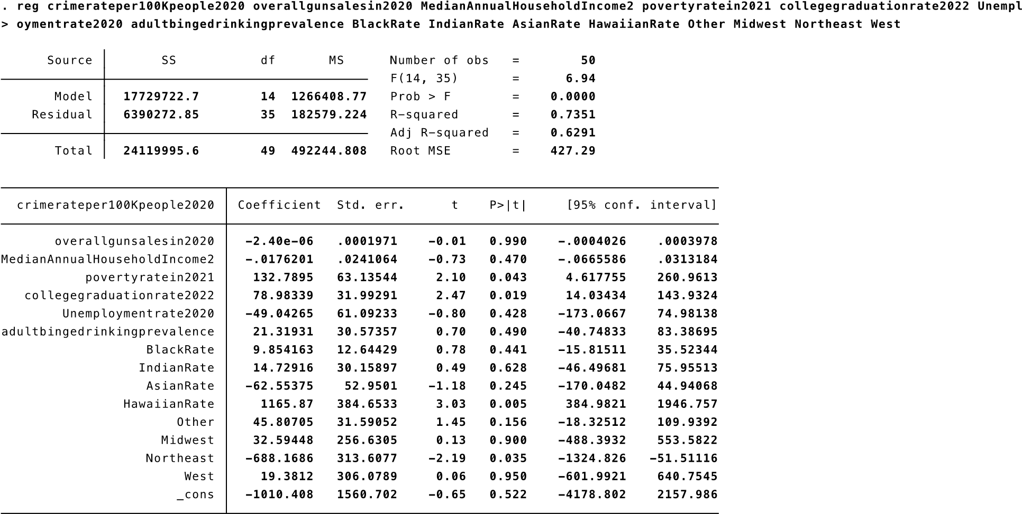

# Additional Test

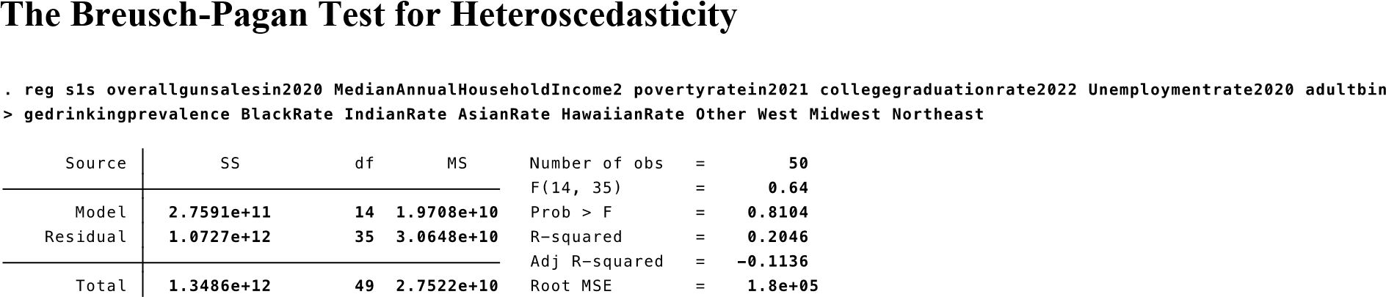

|  |  |  |
| --- | --- | --- |
|  |  |  |
|
|
|  |  | |

Breusch-Pagan Test has P-value (0.6504)>0.05 indicating that we failed to reject the null hypothesis and the F statistic is insignificant. Therefore, the Breusch-Pagan Test for Heteroscedasticity is passed, and no further correction is needed.

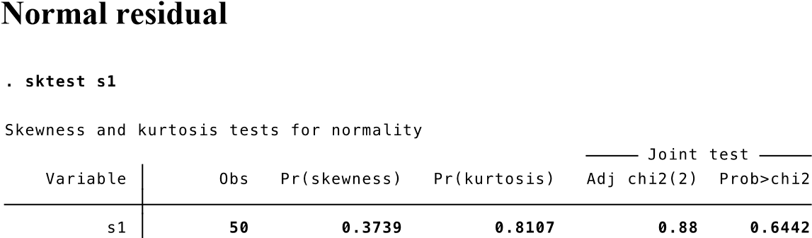

Normality test of residuals has p-value = 0.6442 which is greater than 0.05. Residuals passed the normality test, therefore, the p-values for the t-tests and F-test will be valid. No further correction required.

# Multicollinearity: Variance Inflation Factor (VIF)

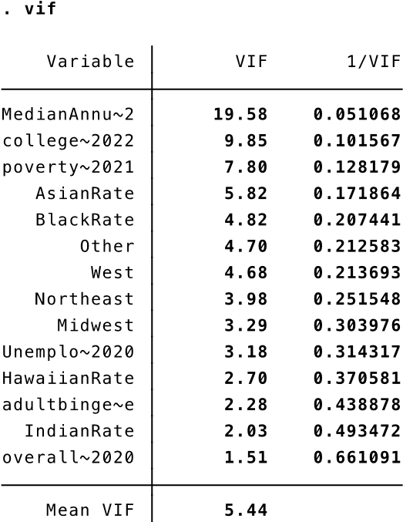

Test result has the mean variance inflation factor (VIF) equals to 5.44 that is within 10, therefore, the regression model passed the multicollinearity test. There is no perfect linear relationship among the predictors.

# Ramsey Test

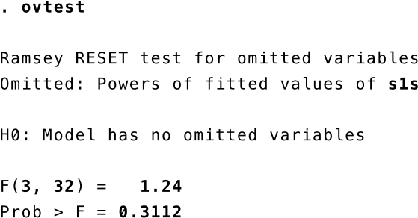

Test result of the regression model has an insignificant p-value (0.3112) greater than 0.05, which imply model passed the test. Therefore, non-linear combinations of the independent variable do not have any power in explaining the response variable.

# Conclusions and Policy Implications

Empirical results indicated the relationship between overall gun sales and crime rate per 100K people is statistically insignificant based on state-level data. In other words, gun sales quantity is not an important and necessary factor to determine and influence the overall crime rate. Result of this research is consistent with the article published by Grey et al (2016), Mathew (1983), and Douglas (2014). The national level, state level, and city level data all point out the insignificance relationship between gun laws and crime rate. Secondly, poverty as one of the variables has a statistically significant relationship with crime rate. This research result is consistent with Ik-Whan G et al. (2010) that socioeconomic and low enforcement factors significantly affect the level of crime rate.

Even though research findings and related articles point to a statistically insignificant association between gun control and crime rates, gun-related crimes keep happening and most people still easily associated guns with violence, death, and crime. Some research results have a significant association between gun control and suicide rates. Therefore, government and gun control policies are still necessary. The U.S. government established many policies. The most popular gun control acts are bans on violent offenders from purchasing guns, universal background checks for permits on all firearm sales, and the “may issue” in which police have the discretion to issue concealed carry permits (Florida, 2019). These policies have been interpreted by the GCA as effective ways to exclude the population who cannot legally own a firearm due to their age, criminal background, and lack of ability.

The main policy implication for this research is the widespread gun ownership does not contribute to high crime rate. Therefore, if gun control law passed to reduce crime rate, they are likely to fail because gun control is not associated with crime rate. This does not mean that we should stop exploring new variants of gun control, but it does mean that such efforts will have a measurable less impact on crime rates than other options, such as well-evaluated programs to reduce poverty (Walker, 2011).

# References

Cook, P. J. (1983, January 1). *The influence of gun availability on violent crime patterns: Crime*

*and justice: Vol 4*. Crime and Justice. Retrieved October 7, 2022, from https://www.journals.uchicago.edu/doi/10.1086/449086

DeZEE, M. A. T. T. H. E. W. R. (1983, July). *GUN CONTROL LEGISLATION: Impact and Ideology*. Wiley Online Library. Retrieved October 29, 2022, from https://onlinelibrary.wiley.com/doi/epdf/10.1111/j.1467-9930.1983.tb00304.x

Edwards, G. (2006, April 1). *Murder and gun control*. American Journal of Psychiatry.

Retrieved October 7, 2022, from https://ajp.psychiatryonline.org/doi/abs/10.1176/ajp.128.7.811

*Everytown Research - EveryStat*. EveryStat.org. (n.d.). Retrieved October 28, 2022, from https://everystat.org/

Florida , R., & Javorsky, N. (2019, April 5). *The 3 gun-control laws that work best in the U.S.* Bloomberg.com. Retrieved October 7, 2022, from https://www.bloomberg.com/news/articles/2019-04-05/the-3-gun-control-laws-that-work best-in-the-u-s

*Gun violence archive*. Gun Violence Archive. (n.d.). Retrieved October 7, 2022, from https://www.gunviolencearchive.org/reports/mass-shooting

Jonson , C. L., Burton, A. L., Cullen, F. T., Pickett, J. T., & Burton Jr., V. S. (2021, January 15).

*An Apple in one hand, a gun in the other: Public ... - wiley online library*. Retrieved

October 8, 2022, from <https://onlinelibrary.wiley.com/doi/10.1111/1745-9133.12538>

Kleck, G., Kovandzic, T., & Bellows, J. (2016, October 4). *Does gun control reduce violent crime? - sage journals*. sage journals. Retrieved October 29, 2022, from https://journals.sagepub.com/doi/full/10.1177/0734016816670457

Kwon, I.-W. G., Scott, B., Safranski, S. R., & Bae, M. (2010, August 24). *The Effectiveness of*

*Gun Control Laws: Multivariate Statistical Analysis*. wiley online library. Retrieved

October 29, 2022, from https://onlinelibrary.wiley.com/doi/10.1111/j.15367150.1997.tb03449.x

Lynch , D. (2022, June 1). *A week after Uvalde shooting rampage, five remain hospitalized*.

kens5.com. Retrieved October 7, 2022, from

https://www.kens5.com/article/news/special-reports/uvalde-school-shooting/uvalde-texas

-school-shooting-teacher-gunman/273-096e6679-e944-472e-979a-b7beec9fc695

Morrissey, J. (2022, March 31). *Economic impact of the U.S. firearm industry reaches $70.52 billion in 2021*. NSSF. Retrieved October 7, 2022, from https://www.nssf.org/articles/economic-impact-of-the-u-s-firearm-industry-reaches-70-52

-billion-in-2021/#:~:text=The%20total%20economic%20impact%20of,the%20firearm%

20industry%20trade%20association.

Murray, D. R. (2014, August 2). *Handguns, gun control laws and firearm violence\**. OUP Academic. Retrieved October 28, 2022, from https://academic.oup.com/socpro/articleabstract/23/1/81/1609209#no-access-message.

Rep. Nadler, Jerrold. (2022, May 31). *H.R.7910 - 117th Congress (2021-2022): Protecting our kids act*. Retrieved October 8, 2022, from

<https://www.congress.gov/bill/117th-congress/house-bill/7910>

*The 2nd amendment of the U.S. constitution*. National Constitution Center – constitutioncenter.org. (n.d.). Retrieved October 7, 2022, from https://constitutioncenter.org/the-constitution/amendments/amendmentii#:~:text=A%20well%20regulated%20Militia%2C%20being,Arms%2C%20shall%20not %20be%20infringed.

Veronica, N., & Horvatits, C. (2022, May 24). *Buffalo supermarket mass shooting: What we know about the victims*. News 4 Buffalo. Retrieved October 7, 2022, from https://www.wivb.com/news/buffalo-supermarket-mass-shooting-tops/victims-names-wh at-we-know-buffalo-supermarket-mass-shooting-what-we-know/

Walker S. (2011). *Sense and nonsense about crime, drugs and communities*. Belmont,

CA: Wadsworth.